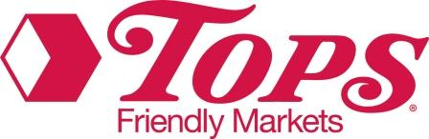

Learner Community
Administrator Guide

Learner Community – Administrator Guide

Logging in

Your Username & Password is your Employee ID number (begins with 7700)
Your first time logging in you will be prompted to change your password – we recommend continuing to use your Employee ID as your new password for consistency. Type that number into the old password and the new password fields if you choose to use the same one, or create a new password.

You can view the Catalog or My Learning Activities via the tabs on the home page. To log into the “Admin Dashboard”, you can click on the link at the bottom of the home screen, or click on the arrow next to your name, at the top right of the screen.

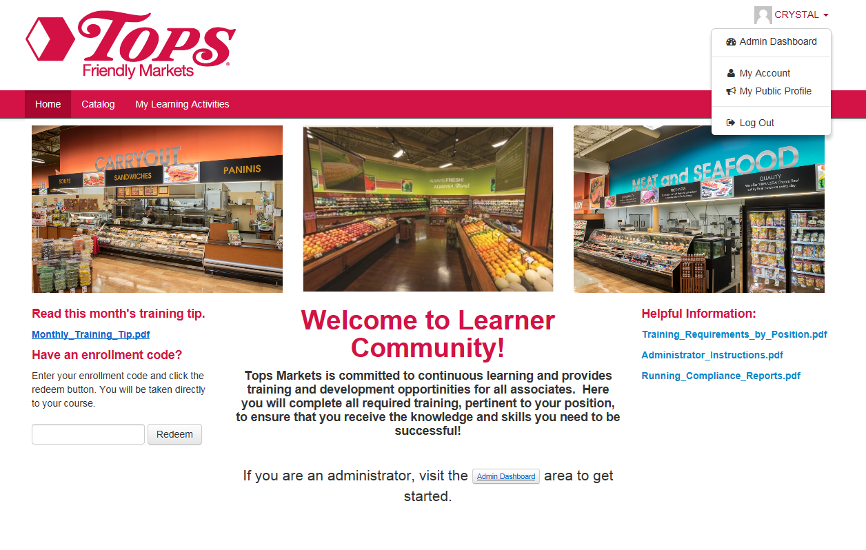

Catalog

The Catalog is in alphabetical order by course title. To narrow down a search, you can also choose a particular category, or you can search by course name in the search field.
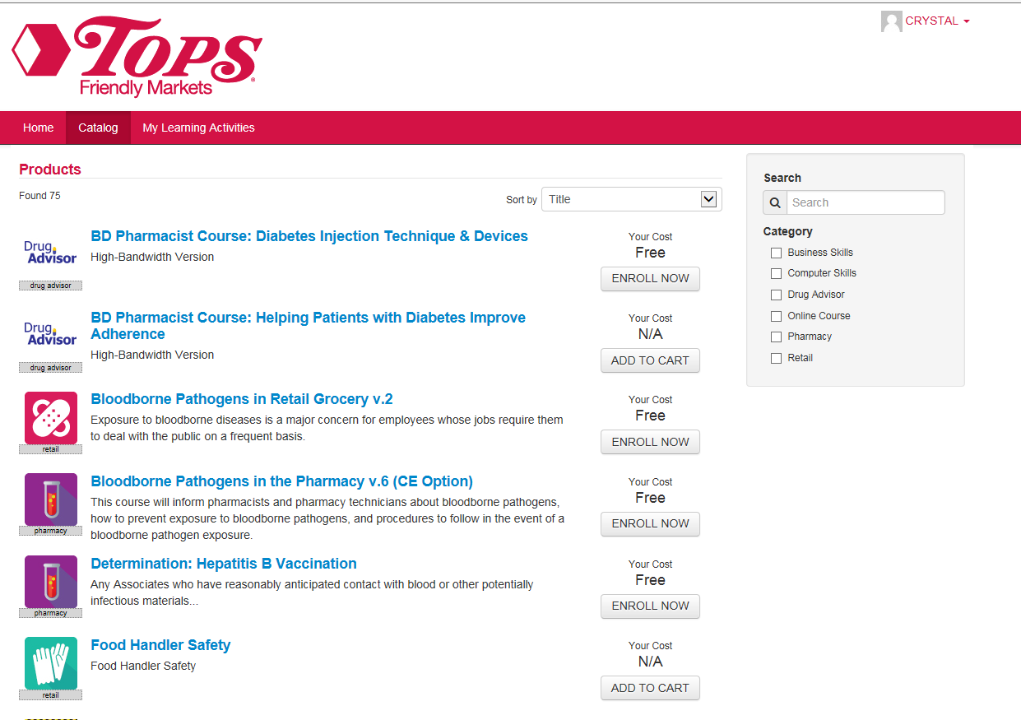

Dashboard View

Here you can manage Learners, run reports, and add course enrollments.

Under the Learners heading, choose Manager Learners to search for someone by name or ID to view their course enrollments, completions and assignments.

An Enrollment is a course that you, as the admin, (or the Learner) adds to their page.

An Assignment is anything that is set up as rule - based which is determined by job code. Certain courses are automatically assigned based on jobcode in the payroll system.

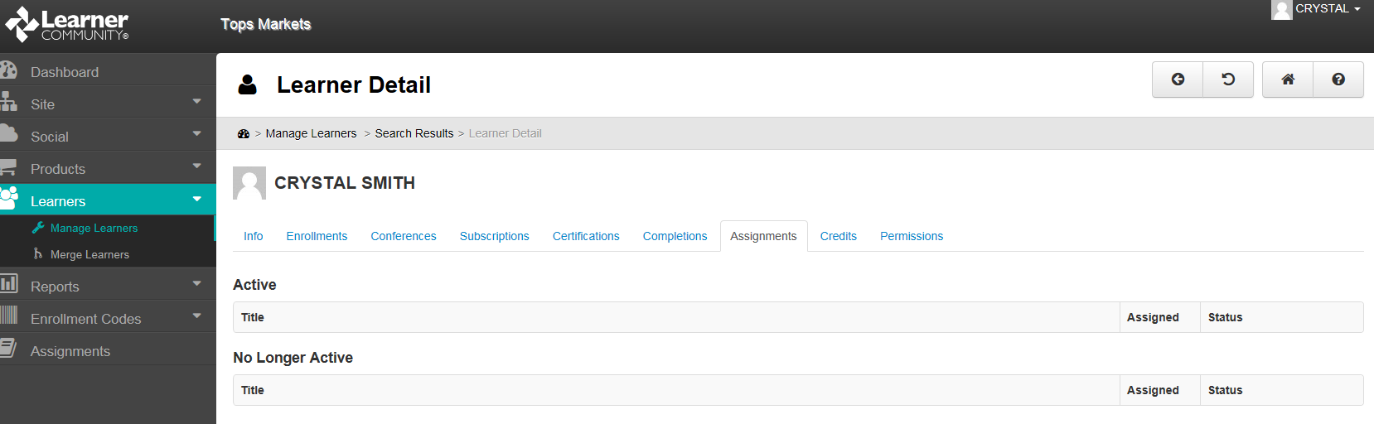

Reports

Standard reports include:

Learner Registration – run this report if you need a list of your Employee’s ID numbers
Assignment Detail – run this report to see which learners have completed or not completed an assignment (these are courses automatically assigned based on jobcode).
Enrollment Detail – run this report to see which learners have completed or not completed an assignment (these are courses added manually which are not automatic assignments).
Compliance Analysis – this lets you view assignments, alerts, and completion data for Learners in each assignment. This is only for automatic assignments (not course enrollments added manually).

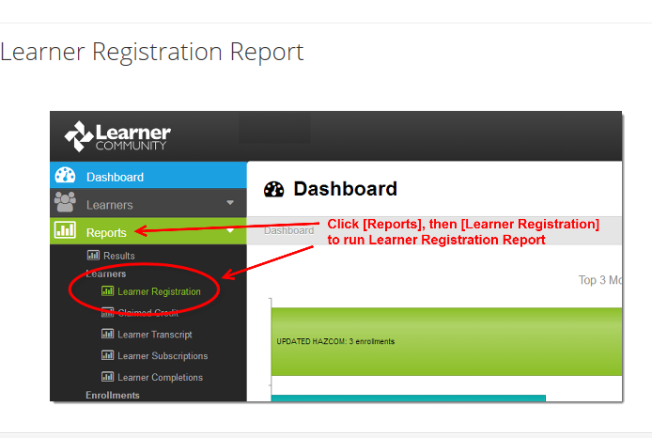
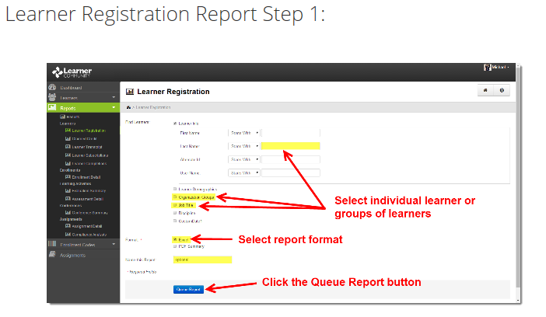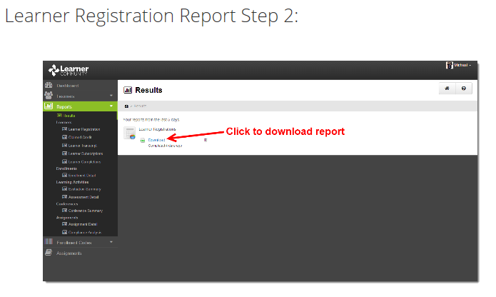

Assignment Detail Report
This report lets you view assignments completion and incompletion data for groups and individuals in each assignment. This will only show you information on assignments automatically set up based on jobcode!
- Report By Product(s) or Assignment(s) from the provided list or find one using the Search field.
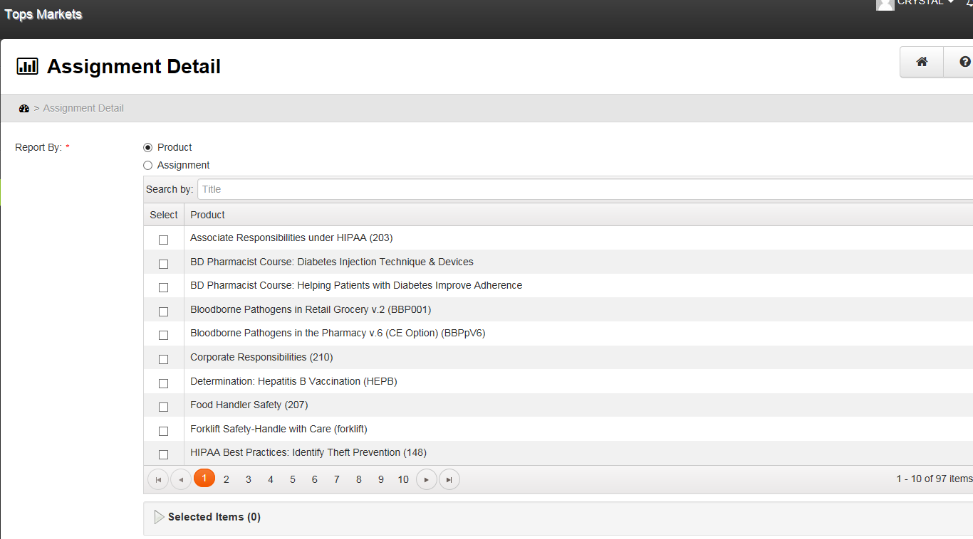
- Selecting the Learner Info checkbox (already selected by default) lets you filter the report to individual learners by Name, or User Name. Uncheck the Learner Info box if you wish to run the report for an entire group/store.
- The Active learner Status is selected by default. Click the Deleted checkbox to include learners with a deleted status.
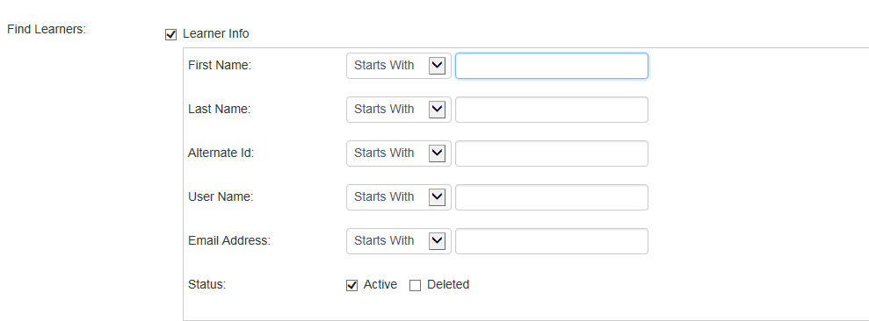
- Optionally select a Due Date by entering a Start Date and End Date using the pop-up calendar.
- Choose a learner Overdue Status: Overdue, Not Overdue or both.
- Choose a Completion Status: Completed, Not Completed or both.
- Optionally enter a name in the Name this Report field.
- Click to generate the requested report.
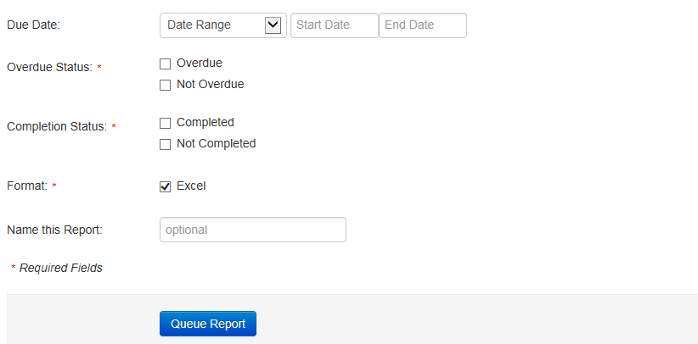
Enrollment Detail Report
This report lets you view enrollment completion and incompletion data for Learners. This will only show you information on enrollments that were set up manually, not on assignments automatically set up based on jobcode. **This report runs enrollments made as of November 1, 2016.
Choose the Learning Product/s you wish to view.

Choose a particular enrollment timeframe, completion timeframe and/or enrollment status if you wish.

Selecting the Learner Info checkbox (already selected by default) lets you filter the report to individual learners by Name, or User Name. Uncheck the Learner Info box if you wish to run the report for an entire group/store.

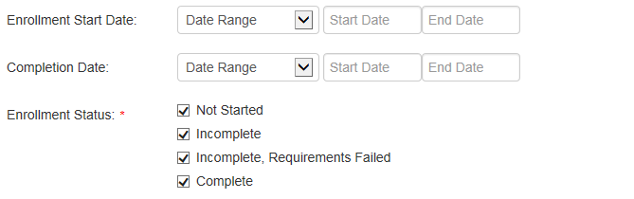

Include any additional detail you wish to see.
Choose the format you wish to run.
Optionally enter a name in the Name this Report field.
Click to generate the requested report.
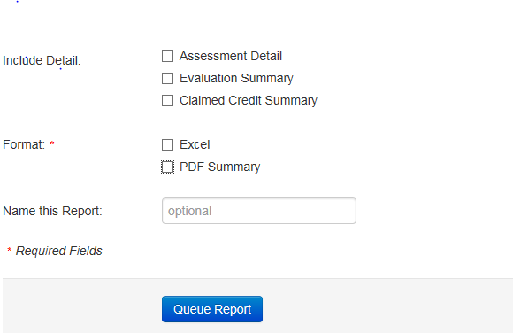

Reports – Compliance Analysis
This report lets you view a list of assignments, and alerts and completion data for groups and individuals in each assignment. This will only show you information on assignments automatically set up based on jobcode.
- Each assignment will provide a compliance level: Complete, Incomplete, Near Non-Compliant, Non-Compliant.
- Click the icon beside an assignment title to view and see a list of the learners included in the assignment.
- Click a learner's name to view details of their compliance. This will display the Title, Assigned date, and Status of both Active and No Longer Active assignments.
- Click the icon beside an assignment name to drilldown and view the compliance details for products within the assignment.
- Click the icon to remove an assignment from the analysis.
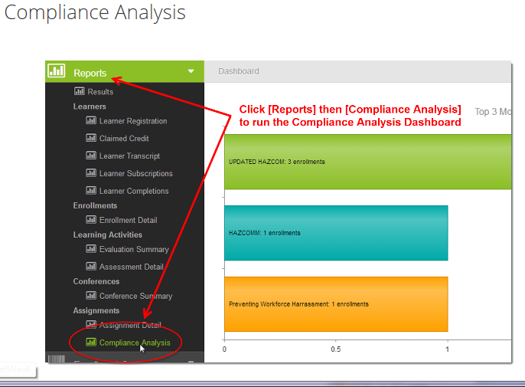
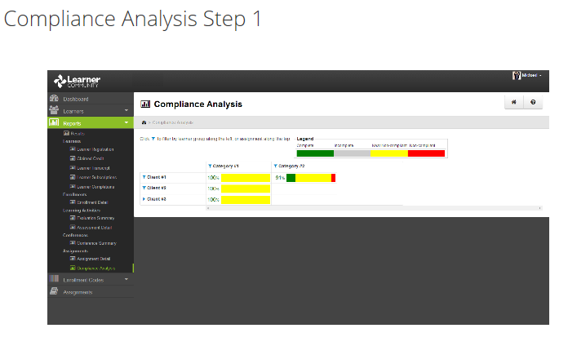
Add an Enrollment
Under Manage Learners: Find the Learner to go to their page.
Go to the Enrollments Tab.
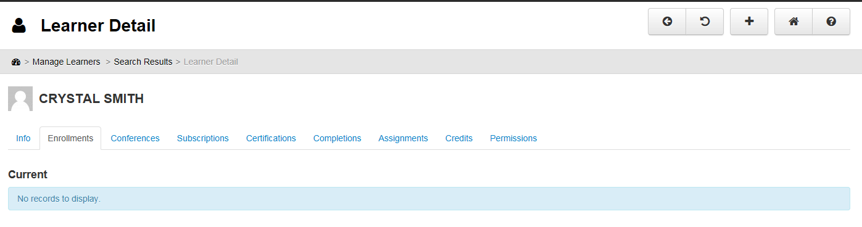
- Click the 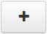 button to add a new enrollment to the learner's account.
- Select the Learning Product to be added and click the button.
- The new enrollments will be added to the Pending table and will remain pending until the learner logs in and accesses their account.
- Enrollments added by an administrator will honor the Default Term Days from the learning product. If the term days start when the enrollment is fist viewed, the countdown will not begin until the learner accesses the enrollment. If the term days start when the enrollment is created, the countdown will start immediately after you add the enrollment.

Delete an Enrollment
Under Manage Learners – Enrollments – click on the trash can next to the appropriate enrollment
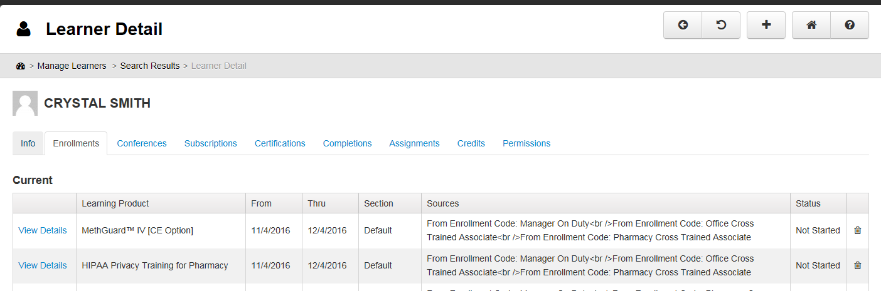
Enrollment Codes
For convenience and accuracy, Enrollment Codes have been created to add a bundle of courses to a particular learner.
This is assigned directly from the Learner’s page, not under the Admin function.
Enter the appropriate Enrollment Code and Redeem.
Office Cross Trained Associate - Enter OFCTRAIN as the Enrollment Code
Manager on Duty – Enter MOD as the Enrollment Code
Pharmacy Cross Trained Associate - Enter RXTRAIN as the Enrollment Code

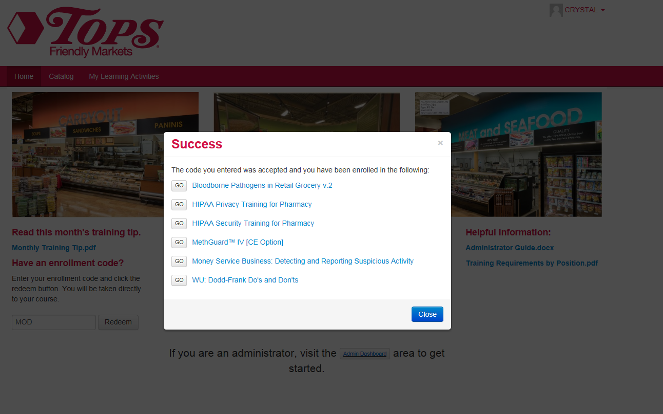

Transcript Report
To run a Transcript of all course completions for a learner, have the learner log in (or log on as them) and then next to their name in the drop down, choose My Account. Click on the Transcripts Tab, choose Completions, and then Print Transcript.
